Bitcoin Day Trade Price Forecast

# Abstract

Stock Market prediction has been a matter of high interest, from financial sectors to individual traders, for many years. Different approaches, using technical indicators and statistical analysis, have been implemented, as well as the use of Machine Learning Algorithms. The purpose of this project is to develop a model for short-term prediction, for day trade strategies, of the price fluctuation for the cryptocurrency of Bitcoin in the Bitstamp Exchange. The dataset used for this project is available at Kaggle with the historical minute-to-minute update of OHLC (Open, High, Low, Close), Volume in Bitcoin and in USD, as well as the weighted bitcoin price, from December 31, 2011 to August, 2019. The techniques implemented will be of time-regression analysis and recurrent neural networks, utilizing R, Python and Tableau for data visualization.

# Introduction

Stock Market forecast has always been a common interest in the financial market. Several methods involving statistical, technical analysis are daily applied towards defining trading strategies for long or short periods. With the develop of Neural Networks algorithms, many advents of trying to use this technology have been studied to increase prediction’s accuracy and stability.

Cryptocurrency, such as Bitcoins, have been the focus of many traders for the past few years. Having a volatile trading history with high price increases and drops in 2013 and 2018. Typical trading strategies can involve buying and selling during medium to long periods, e.g days and weeks. Other type of strategy, is performing operations within each day, i.e intraday or day trading. The later benefits from short-term price fluctuation typically using periods of one, five, fifteen, thirty and sixty minutes (Seagal 2019).

The objective of this project is to verify to what extent can applying Neural Networks help forecast the next minutes of Bitcoin prices within a day fluctuation, using previous data and statistical indicators.

# Literature Review

## In this chapter the history of cryptocurrency and its exchange market, as well as statistical models, technical analysis, and Neural Network applications towards stock price forecasting are reviewed.

## 2.1. Cryptocurrency

## Cryptocurrencies are defined as digital tokens commodity, that are used as digital store of value (Hougan, Kim, & Lerner, 2019). They utilize a cryptography system that works as an anonymized ledger of financial transactions called Blockchains, to allow secure transfer in a distributed and decentralized manner (Sundararajan, 2016). The main idea of the cryptocurrency is to allow parties to transact directly without the need for a trusted party (Nakamoto, 2008). In 2009 cryptocurrency Bitcoin emerges, and since then it has matured significantly into a large network of computers around the world.

## Cryptocurrency exchange market

## Whilst envisioned as a peer-to-peer digital currency, bitcoin and other cryptocurrencies soon demanded a grow in electronic trading venues to facilitate trading. Exchanges can be used to buy, sell and trade cryptocurrencies for other cryptocurrencies or physical currencies, allowing buyers and sellers to negotiate prices offering liquidity and setting a reference (Hileman, Rauchs ,2017). The first exchange was founded in 2010 and since then many other exchange markets have been created, dealing with a variety of cryptocurrencies. The largest crypto exchanges today are sizeable enterprises based in different countries around the world.

## Stock prediction a statistical time series approach

## Stock prediction is defined as predicting the future stock price using the historical data. Since the stock market information is a collection of variables over time it can classified as a time series. As described in Guida (2019) typical statistical models applied for time series analysis include autoregressive (AR) models, moving averages (MA) models, mixed autoregressive moving averages models (ARMA) models, seasonal models, unit-root nonstationarity, regression models with time series errors, and differenced models for long-range dependence. For multivariate time series analysis Vector autoregression (VAR) models are one of the most widely statistical methods applied. All these models attempt to capture the linear relationship between the current time step (t) and the information available prior to time t. Correlation plays an important role in understanding these models. In particular, correlations between the variable of interest and its past values correlations.

## Stock prediction a Technical Analysis approach

## Technical indicators are a standard method for analyzing stock price variation. Technical analysis relays totally on company’s stock price in market, and volume trade on a particular price (Shah, Parth, 2015), and use charts and indicators to show the current trend and trend reversals. Some important technical indicators include: Relative Strength Index (RSI), Moving Average Convergence Divergence (MACD), Stochastic Oscillator (Stoch), Rate of change (RoC). (Technical Indicator and Overlay, 2020)

## Stock prediction a Neural Network approach

# As Bhat & Kamath (2013) elucidates “the development of technology and mathematics various new technological methods have been proposed for stock price prediction, which are applied along with technical methods. Genetic Algorithm (GA), Support Vector Machine (SVM), or Neural Networks (NNs) etc. have been applied to predict Stock prices.” (p 1).

# A common family of neural networks used for time series forecasting are called recurrent neural networks (RNN). Differing from the normal feed-forward NNs, RNN are capable to capture the temporal context in its feedback connections, which are capable of capturing the time varying dynamics of the underlying system (Bianchi et al. 2017).

# Dataset

The dataset for this project is publicly available at www.kaggle.com/mczielinski/bitcoin-historical-data with a CC BY-SA 4.0 license that allows share and adapt the dataset for any purpose, even commercially. The dataset was first created by extracting the information from the exchange (Bitstamp) utilizing an API. For the purpose of this project the dataset is already in a csv file with minute to minute updates of OHLC (Open, High, Low, Close), Volume in BTC and USD, and weighted bitcoin price. The data also have a Timestamp in Unix time. Timestamps without any trades or activity have their data fields filled with NaNs. If a timestamp is missing, or if there are jumps, this may be because the exchange (or its API) was down, the exchange (or its API) did not exist, or some other unforeseen technical error in data reporting or gathering.

## Data Exploration

Code Available at: https://github.com/kmaciver/Ryerson_Capstone/tree/master/Data_Cleaning

Initial Dataset is comprised of 8 variables and 3.997.697 observations. Where the variables present the following data types:

|  |  |  |
| --- | --- | --- |
| **Variable** | **Data Type** | **Description** |
| Timestamp | int | Unix time for every minute |
| Open | num | Open-price of Bitcoin for every span of one minute |
| High | num | High-price of Bitcoin for every span of one minute |
| Low | num | Low-price of Bitcoin for every span of one minute |
| Close | num | Close-price of Bitcoin for every span of one minute |
| Volume_.BTC. | num | Volume of Bitcoin transacted for every span of one minute |
| Volume_.Currency. | num | Volume of USD transacted for every span of one minute |
| Weighted_Price | num | Average Price of Bitcoin for every span of one minute |

Table 1 – Data Structure

After Timestamp conversion, and insertion of a date column, the summary of the data set is the following:

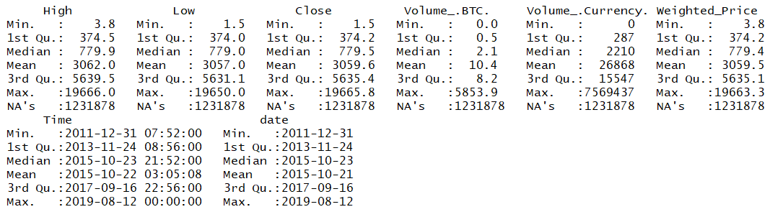

Figure 1 – Data Summary

The figure above illustrates the time range of the data being from December 31, 2011 to August 12, 2019.

Generating initial visualizations:

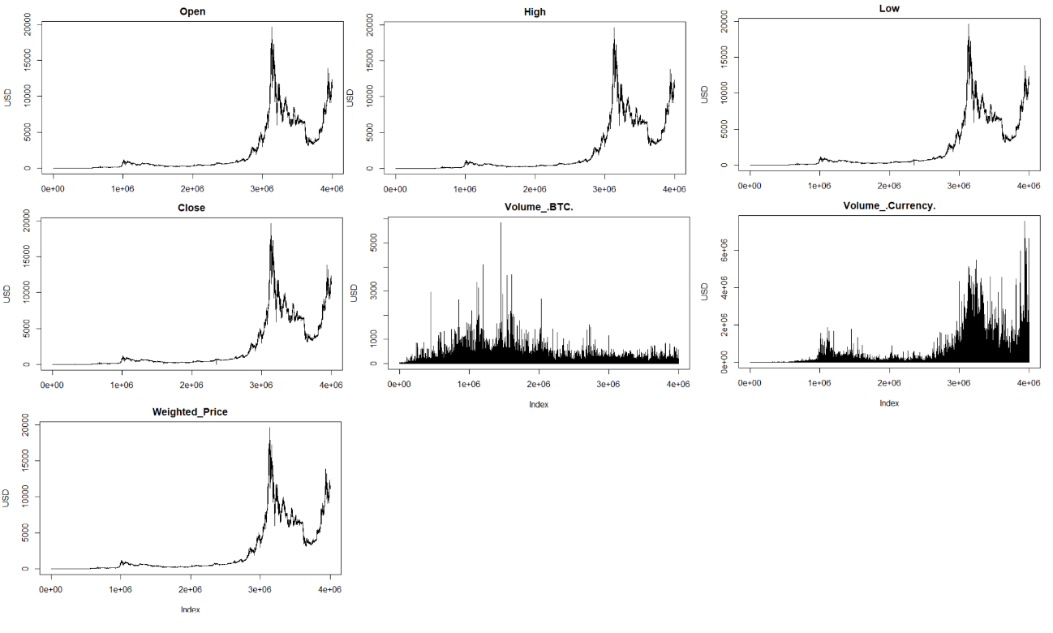

Figure 2 – Variables Plot

Analyzing Variables distribution:

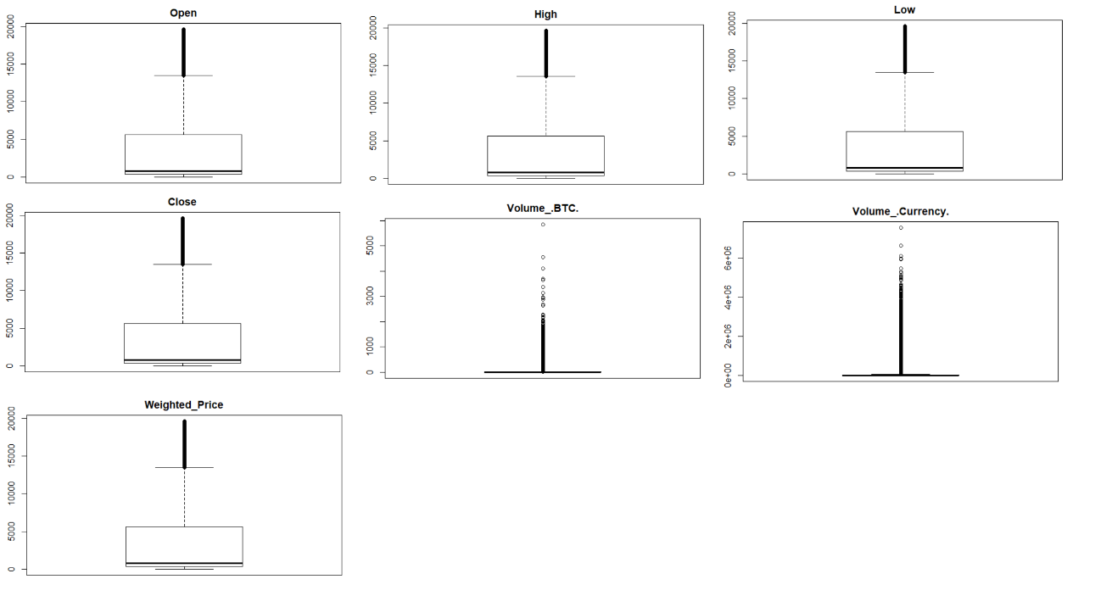

Figure 3 – Boxplots

Although boxplots above describe some considerable number of outliers, the summary of the data shows that there are no negative or other inconsistent number present. Bitcoin has had a volatile history so outliers are most likely to be present, therefore no treatment for outliers was implemented. The table bellow lists the percentage of outliers present on each variable.

|  |  |
| --- | --- |
| Variable | % Outlier |
| Open | 1.28% |
| High | 1.29% |
| Low | 1.27% |
| Close | 1.28% |
| Volume_.BTC. | 8.31% |
| Volume_.Currency. | 9.97% |
| Weighted_Price | 1.28% |

Table 2 – Outliers

Plotting variables histogram distribution.

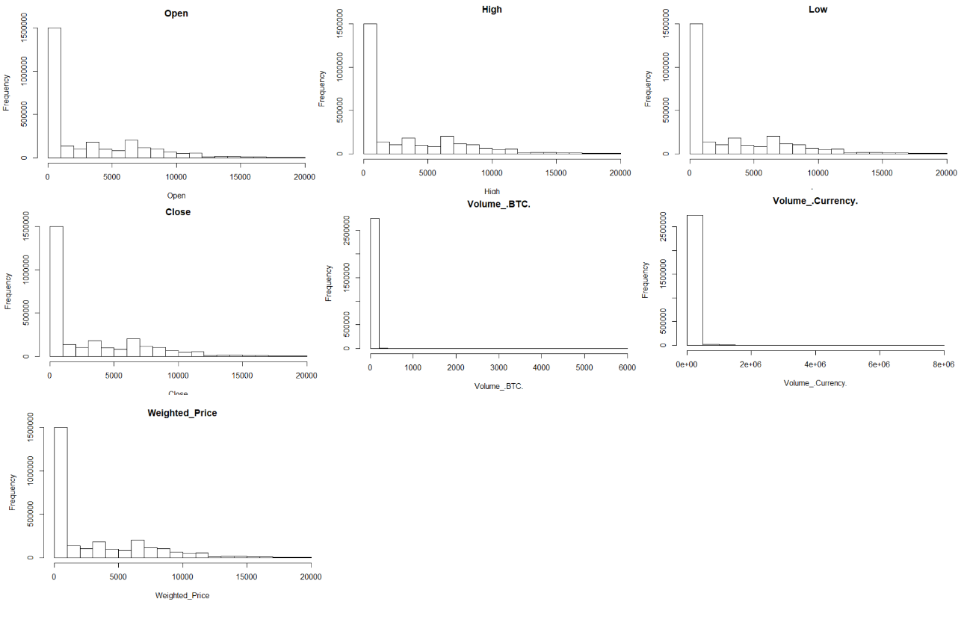

Figure 4 – Histogram

## Data Cleaning

Code Available at: https://github.com/kmaciver/Ryerson_Capstone/tree/master/Data_Cleaning

As showed in Figure 1, the dataset has a considerable amount of missing values. The approach for handling the missing information was to first analyze the distribution of NaN values within each day.

|  |  |
| --- | --- |
| Distribution | % Missing Records per Day |
| Min. | 0.00% |
| 1st Qu. | 4.79% |
| Median | 22.08% |
| Mean | 30.80% |
| 3rd Qu. | 41.60% |
| Max. | 99.93% |

Table 3 – Distribution of Missing Records per day

The table above describes that fifty percent of the days have at least 22.08% of missing records, and an average of 30.8% of missing records within each day.

Sparse data within a day won't be useful for the predicting algorithm. Therefore, only the data of the days that have at most the average percentage of the missing records distribution will be used.

For the remaining missing records, the approach implemented was the insertion of the values corresponded to the previous known value, also taking into account that at the end all days should have 1440 observations, considering that’s the of total minutes of a day.

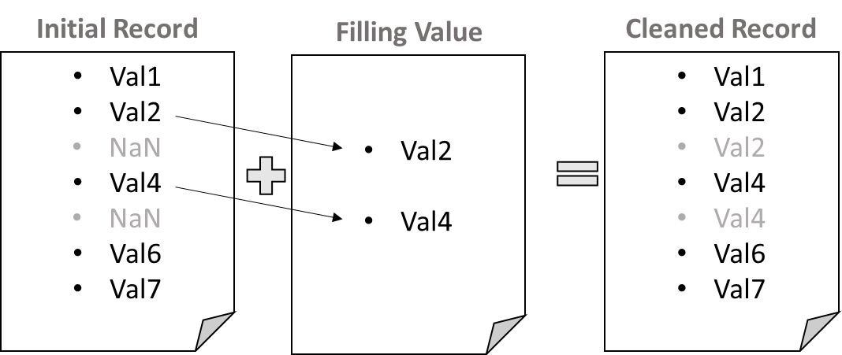

Figure 5 – Missing Record Filling procedure

### Daily Summary Data

The objective of the project is to predict future prices within a particular day. As will be further discussed during the approach and building model paragraphs, two data sets will e used: one containing the price fluctuation in minutes for each day; and one containing a daily summary of the price fluctuation. The later will be used as a boundary for the intraday prediction.

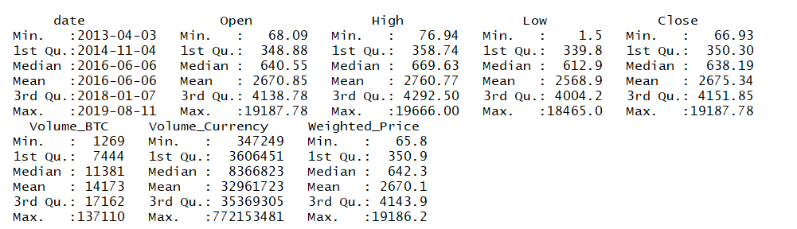

Figure 6 – Daily Summary Data

Although daily summary data didn’t present any missing records, there were still gaps of missing days within the data. Since daily summary will be used for future prediction on variability of data, the data must be continuous throughout the time span. Therefore, missing dates where filled with prior records following the same procedure used previously.

### Technical Indicators

Technical indicators are commonly used in chart technical analysis for stock market forecast. These indicators help identify current trends and trends reversals. Initially, four technical indicators will be added to the dataset.

### RSI

Relative Strength Index (RSI) indicates the overbought and over sold regions and hence the change in momentum. This oscillates between 0 and 100. Above 70 is marked as oversold region and below 30 is marked to be overbought region. RSI can also be used to see the general trend. (Bhat & Kamath, 2013)

Where,

### MACD

Moving average convergence divergence (MACD) has two lines namely MACD line and Signal Line, which give us signals of trend changes with cross overs. These two lines also show the movement of Stock with their coming closer to each other(convergence) and departing from each other(divergence). (Bhat & Kamath, 2013)

Where,

### STOCH

Stochastic Oscillator is a momentum indicator that relates the location of each day's close relative to the high/low range over the past n periods.

Where,

### RoC

Rate of Change indicator finds percentage difference of a series over two observations.

Since all indicators use past values inserting them into the data set generates new missing records.

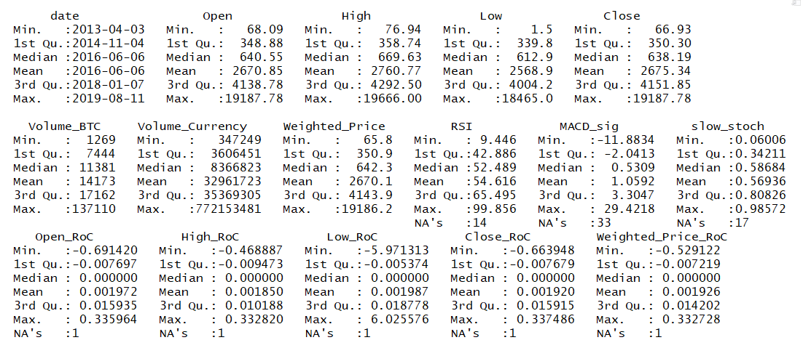

Figure 7 – Daily Summary Data, with Technical Indicators and NaN values

In order to maintain all records, missing records from the RoC technical indicators were filled with 0. For remaining technical indicators, missing value will be filled with the first value known.

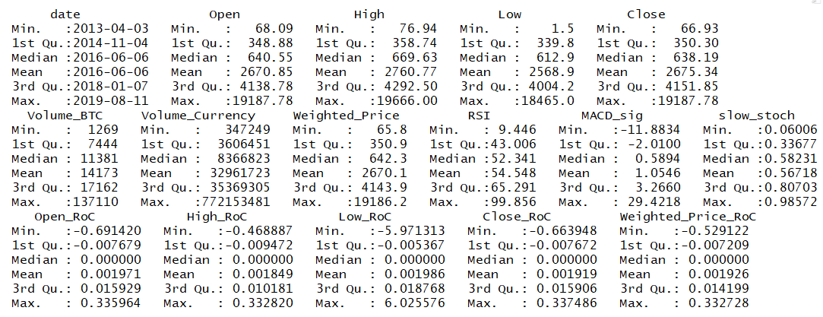

Figure 8 – Cleaned Daily Summary Data, with Technical Indicators

Final size of Daily Summary data is 2322 observations and 16 variables.

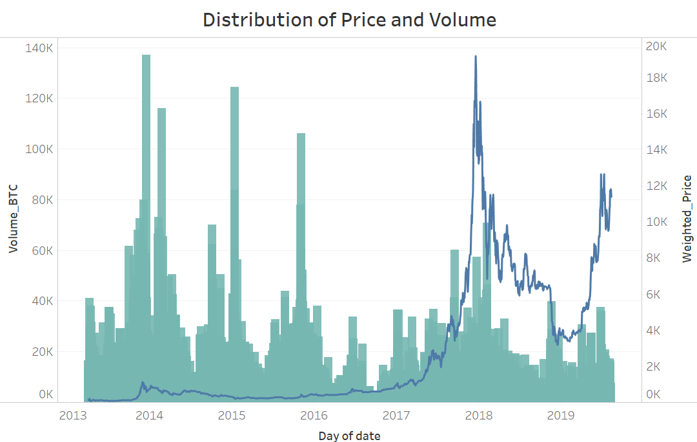

Figure 9 –Daily Summary Data price and Volume

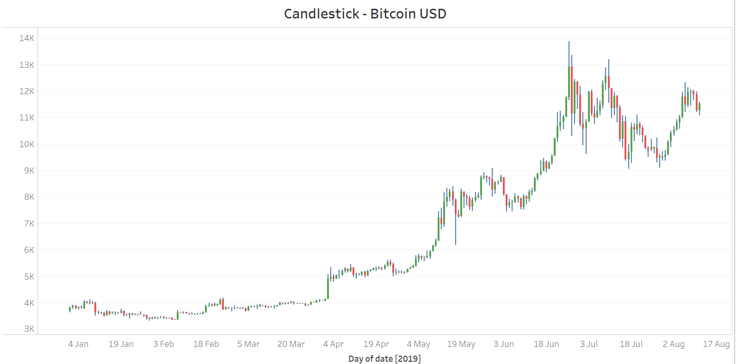

Figure 10 –Daily Summary Data Candlestick chart period of 2019

### Day Trade Data

Following the same steps as before Day Trade Data is created.

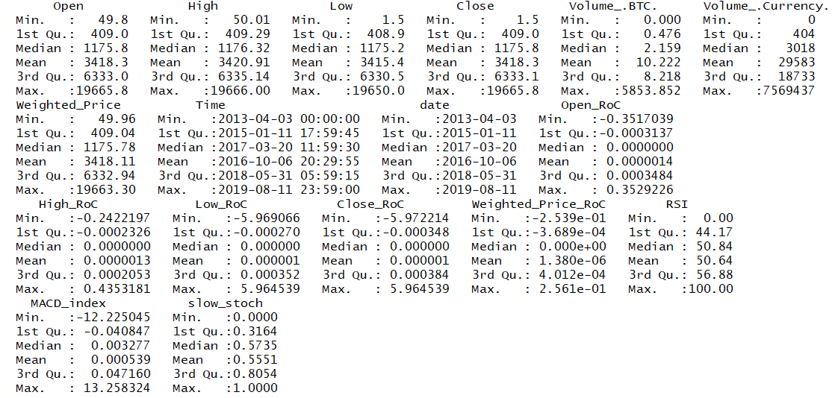

Figure 11 – Cleaned Day Trade Data, with Technical Indicators

Final size of Day Trade data is 2.498.400 observations (1735 days with 1440 observations each) and 17 variables.

# Feature Selection

## Daily Summary Data Correlation

Code Available at: https://github.com/kmaciver/Ryerson_Capstone/tree/master/Data_Cleaning

Analyzing variables cross correlation.

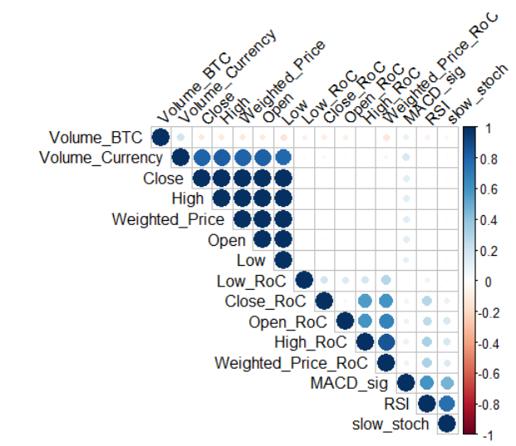

Figure 10 –Day Trade Data correlation plot

The feature Volume Currency is defined as the Volume x Weighted price, which explain the strong correlation with the OHLC and Weighted price attributes.

Slow Stoch, RSI and MACD are strongly correlated since they all have the objective of capturing trend changes.

Although the correlation plot above describes some correlation within features, for time regression analysis the key factor stands on correlation of the past values and the current time period of the label. Since forecasting is the underline objective, feature selection must take into account how the data of the previous times steps affect the prediction of the current time step.

## Daily Summary Data Auto-Correlation

Code Available at: https://github.com/kmaciver/Ryerson_Capstone/tree/master/Data_Cleaning

Auto-correlation function calculate how previous steps of a variable influence the current timestep. In order to apply autocorrelation, the function must first be transformed to a stationary function. When a function is stationary it revolves around a mean of zero, with no seasonality present.

For Daily Summary data, two variables will be used for later predictions: High-price and Low-price.

### Auto-Correlation – High-price Variable

Applying log transformation and lagged and iterated differences for the High variable, the data present the following format

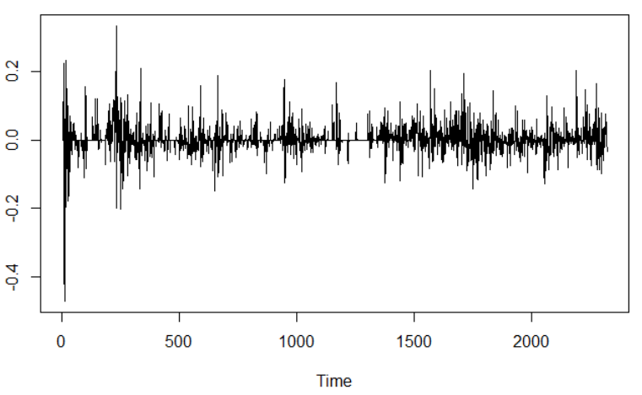

Figure 11 –Stationarity transformation applied to variable High-price

Augmented Dickey-Fuller Test for stationarity:

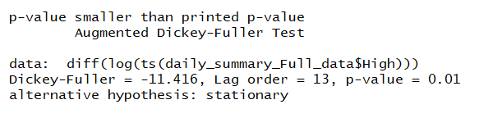

Figure 12 – Augmented Dickey-Fuller Test variable High-price

The results of the Augmented Dickey-Fuller indicates the rejection of the null hypothesis, thus the data can be considered stationary.

Plotting Auto-Correlation function to stationary data:

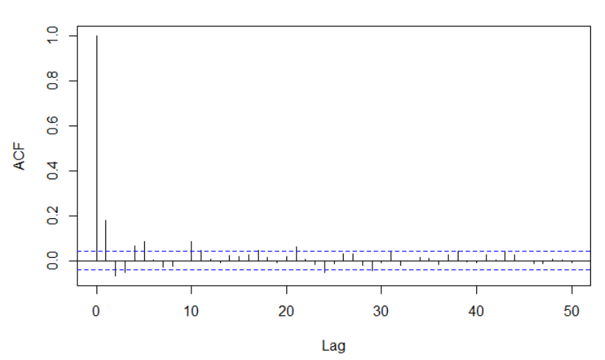

Figure 13 – ACF for Variable High-price

The ACF plot above show significant lag values at 1, 2, 3, 4, 5, 21 and 24 days, for the High-price attribute.

### Auto-Correlation – Low-price Variable

Applying the same function transformation of stationarity for the Low-price variable, and plotting the Auto-Correlation function.

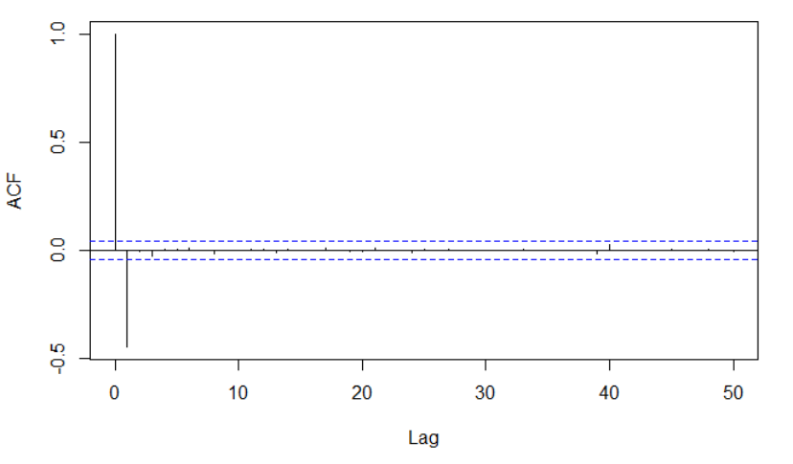

Figure 14 – ACF for Variable Low-price

The ACF plot above show significant lag value at 1 day, for the Low-price attribute.

## Daily Summary Feature Selection

Code Available at: https://github.com/kmaciver/Ryerson_Capstone/tree/master/Feature_Selection

Auto-correlation functions help to evaluate how far back previous time-steps are still influencing the current data, however, ACF can’t capture the cross-influence of previous time-steps of other variables.

In order to capture the importance of each feature with respect to the label, the data was transformed into a supervised learning problem, and feature importance was then calculated using gradient boosting regressor and random forest regression algorithms.

### Transforming Data for Feature Selection

First step was to exclude the Volume Currency data, since it has been previously stated that it is a function of two other variables: Volume BTC and Weighted Price.

For the remaining 14 numeric features in the data, the previous 25 steps where considered, therefore expanding the dataset from 14 to 364 columns.

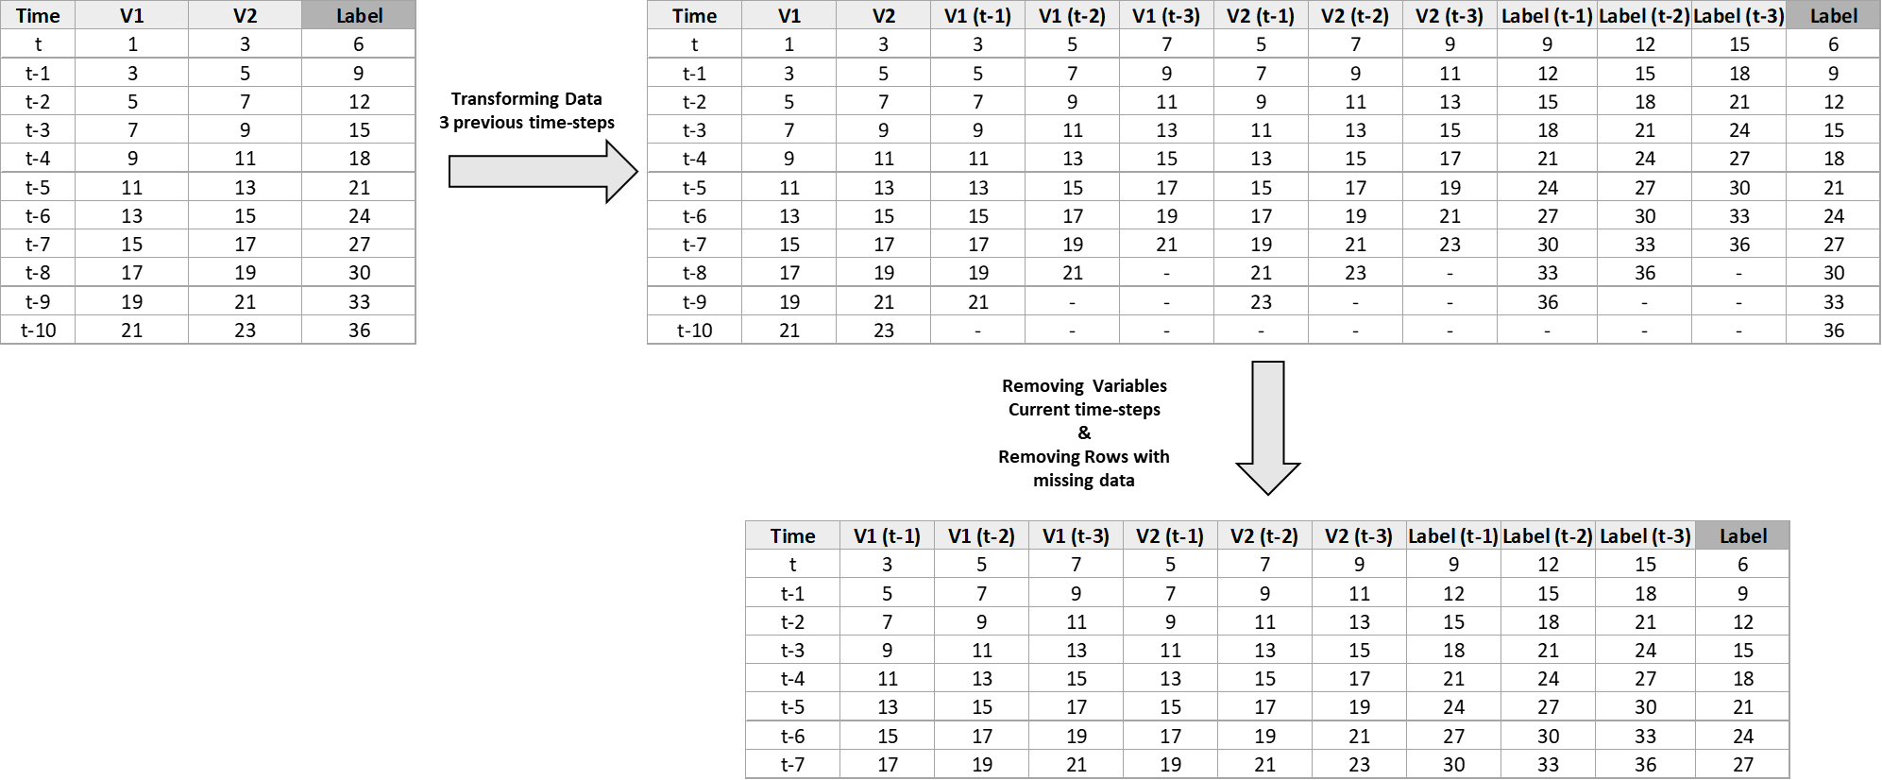

Figure 15 – Illustration of converting data into a supervised learning problem considering three previous time-steps

With the data transformed, stationarity transformations where also applied, followed be applications of random forest regressor and Gradient boosting regressor, where their respective feature importance were calculated. This approach was applied for both High-price as a label and Low-price as a label.

The results of the feature importance calculations are illustrated bellow:

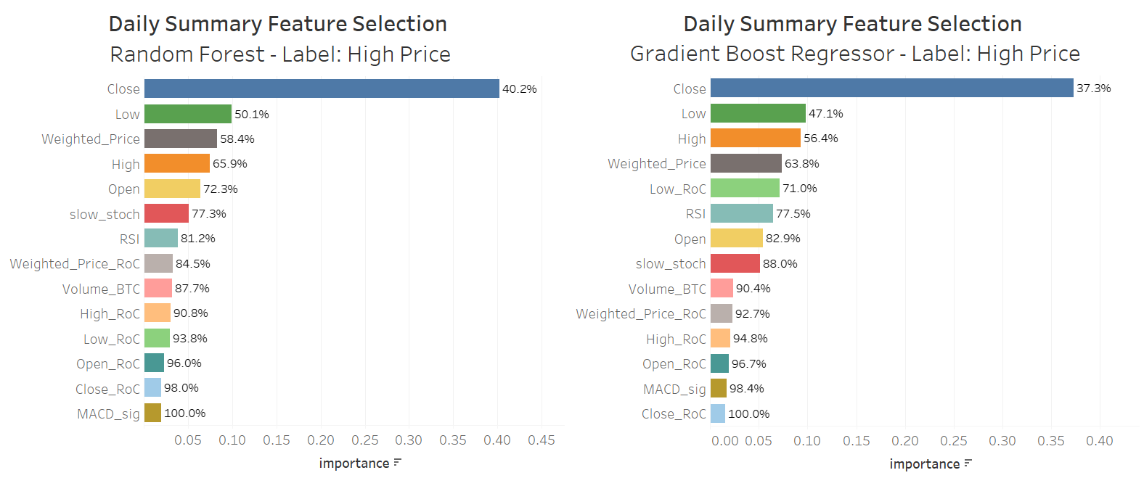

Figure 16 – Feature Importance for Daily Summary Data and High-price as Label

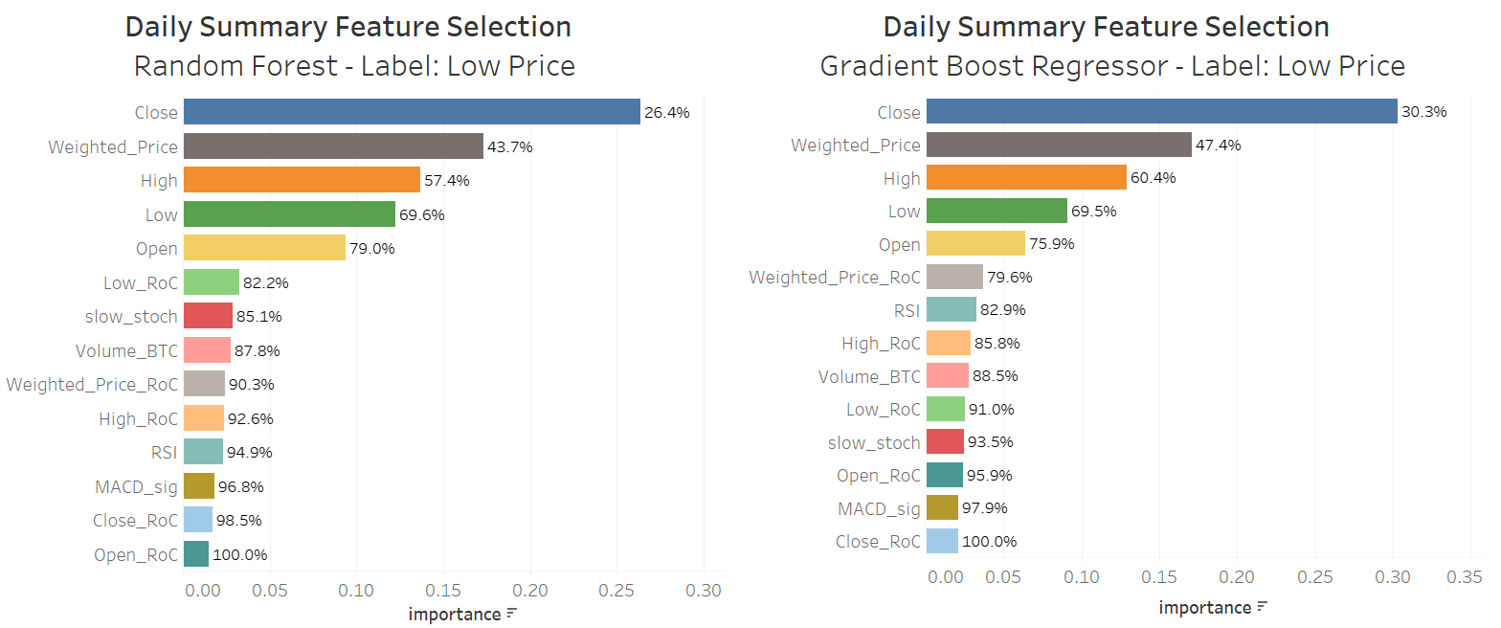

Figure 17 – Feature Importance for Daily Summary Data and Low-price as Label

The results show that for both algorithms, and both labels of Daily Summary, the features: Close_RoC, MACD_sig and Open_RoC, had the lowest importance.

When, calculated feature importance with respect to time lags, the results where the following:

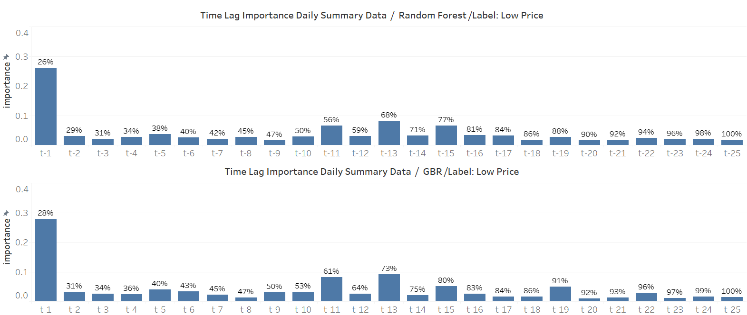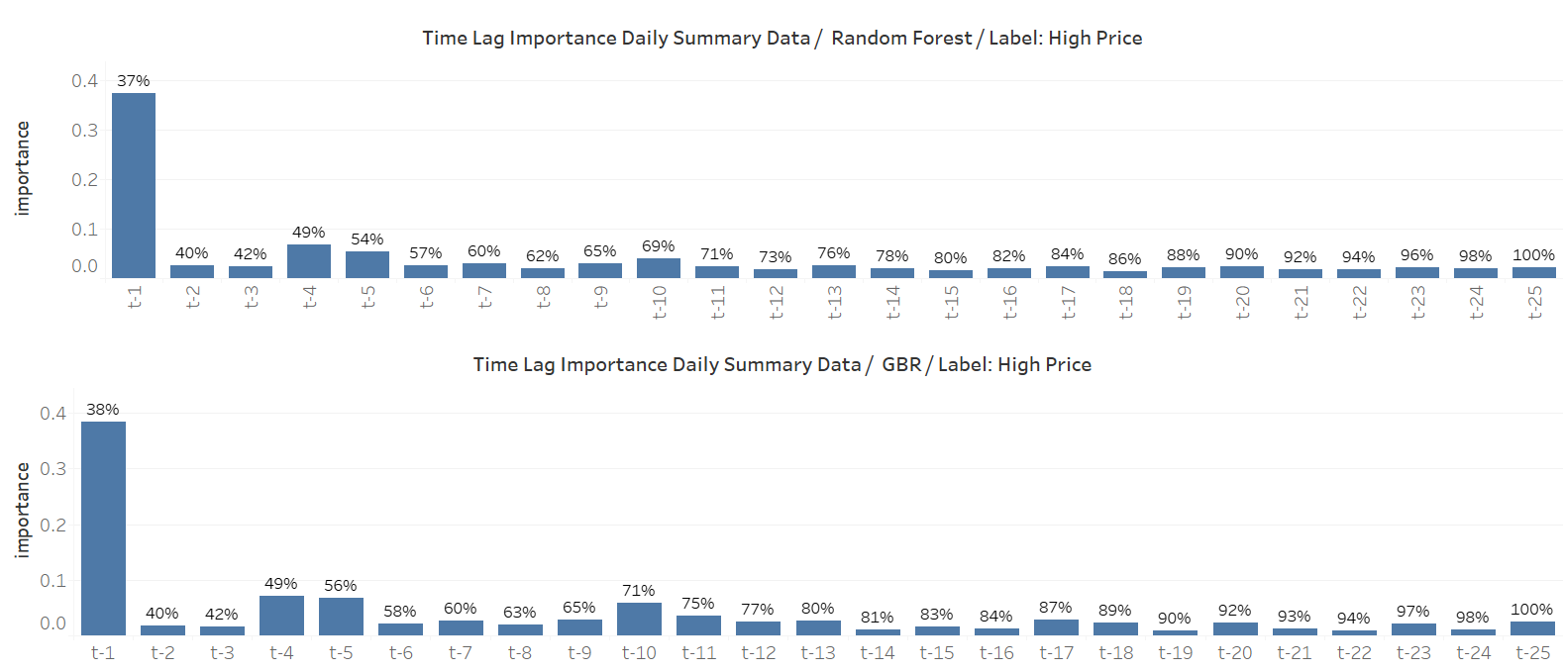

Figure 18 – Time-step Importance for Daily Summary Data for Both Labels and Algorithms

The plots above show that for all labels and algorithms the previous time-step has the higher importance, but is also show that up to the t-25 there is still importance being attributed.

## Day Trade Data Correlation

Code Available at: https://github.com/kmaciver/Ryerson_Capstone/tree/master/Data_Cleaning

Analyzing variables cross correlation.

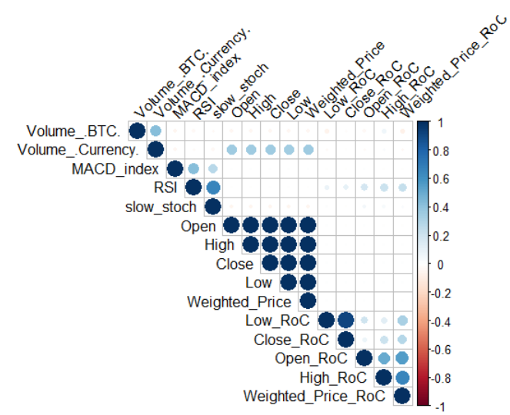

Figure 19 –Day Trade Data correlation plot

## Daily Summary Data Auto-Correlation

Code Available at: https://github.com/kmaciver/Ryerson_Capstone/tree/master/Data_Cleaning

The feature of interest in the Day Trade data is the Weighted Price. Differently, then Daily Summary data, the Day Trade data contains the minute to minute data for a total of 1735 days, and, therefore, the auto-correlation should be analyzed on a day-to-day basis.

### Auto-Correlation – Weighted Price Variable

Sampling random ten days of the Day Trade data, applying log transformation and lagged and iterated differences for the Weighted variable, and calculating the auto-correlation functions, the results were the following:

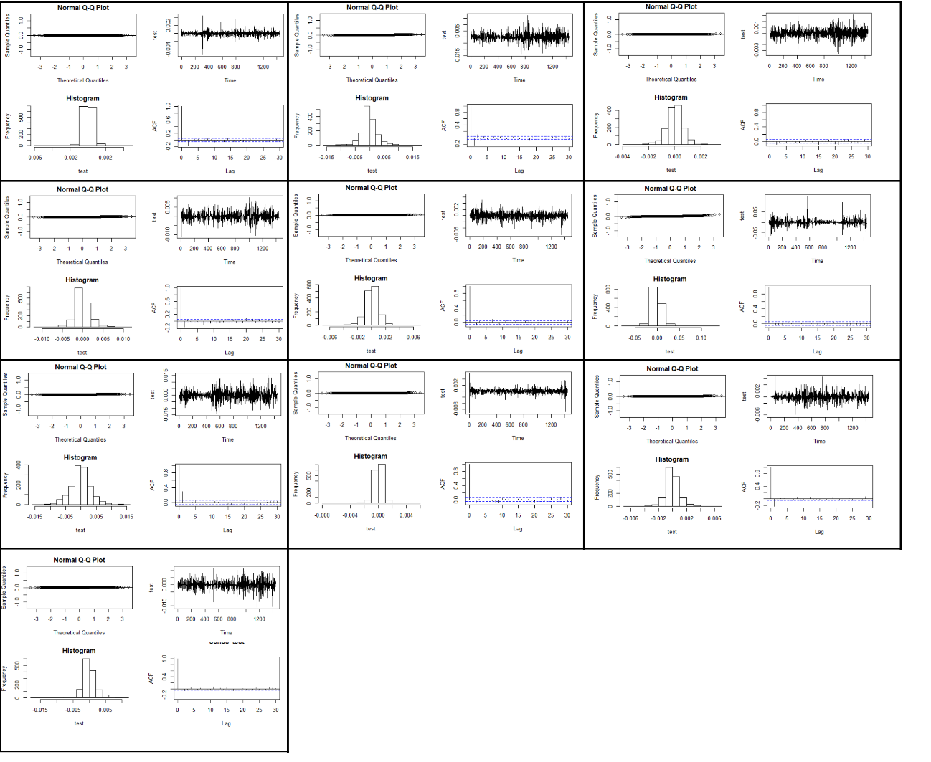

Figure 19 – 10 sampled Days ACF for Weighed Price – Day Trade Data

For all the sampled days the data stationarity was achieved by applying log and diff transformations. Although, the AFC graphs vary in the number significant lagged time steps, it appears the furthest significant lagged value was t-25.

## Day Trade Feature Selection

Code Available at: https://github.com/kmaciver/Ryerson_Capstone/tree/master/Feature_Selection

As described before, Day Trade data must be analyzed in a day-to-day basis. Therefore, a similar approach to the Feature Selection step for Daily Summary was executed, to every date on the data set. The average of the feature importance was the calculated for both of the algorithms.

The results of the feature importance calculations are illustrated bellow:

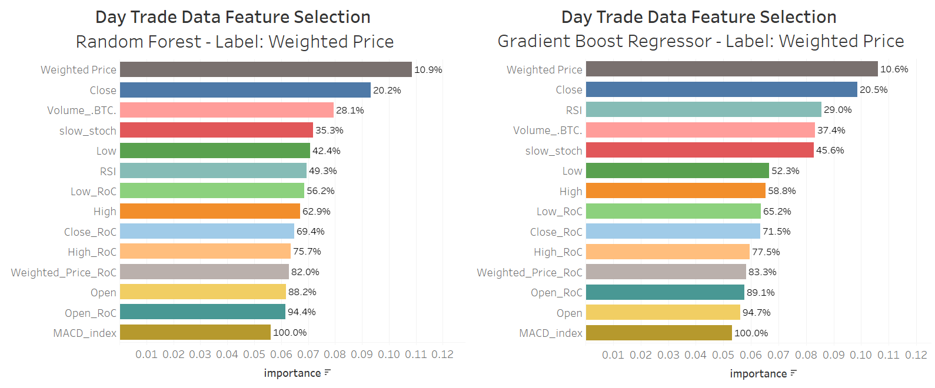

Figure 19 – Feature Importance for Day Trade Data / Label: Weighted Price

The results show that for both algorithms, the features: Open, Open_RoC and MACD_index had the lowest importance.

When, calculated feature importance with respect to time lags, the results where the following:

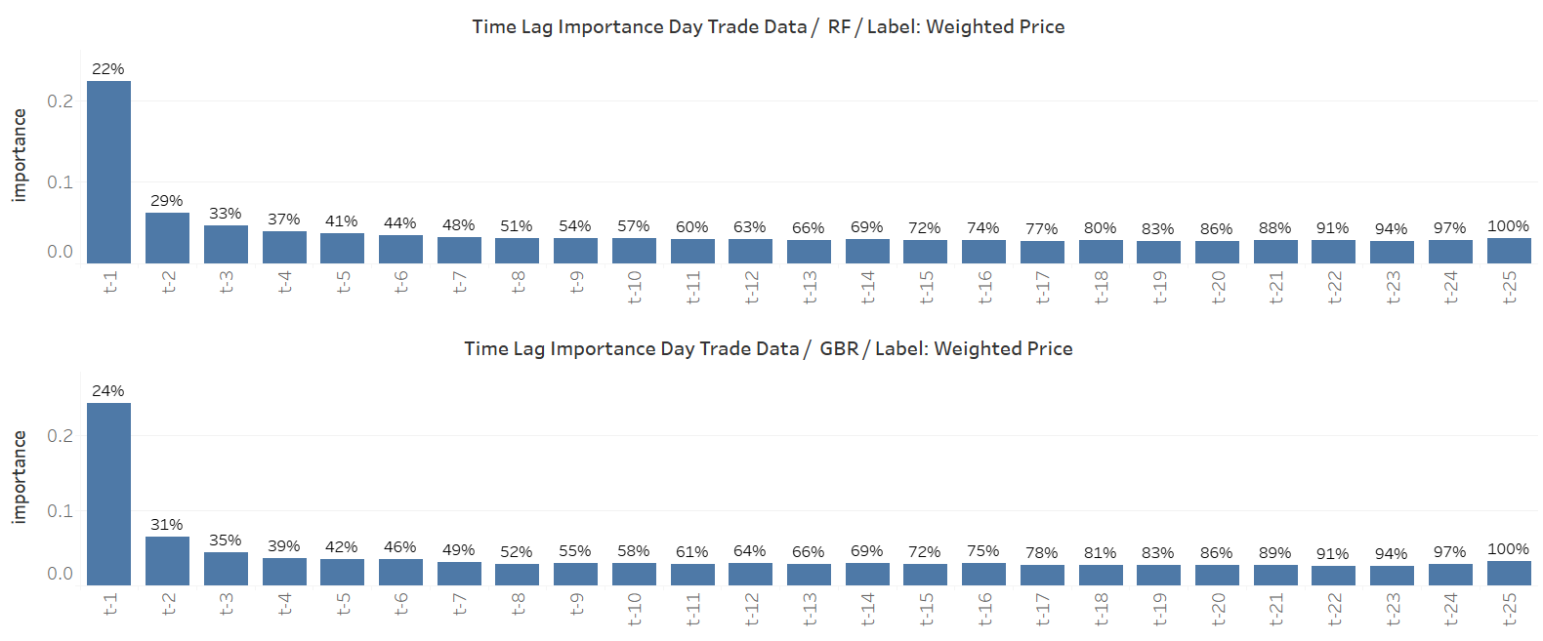

Figure 18 – Time-step Importance for Day Trade Data for Both Algorithms

The plots above show that for all labels and algorithms the previous time-step has the higher importance, but is also show that up to the t-25 there is still importance being attributed.

# References

[1] Bhat, A., Kamath, S. (2013). Automated Stock Price Prediction and Trading Framework for Nifty Intraday Trading. Conference: 2013 Fourth International Conference on Computing, Communications and Networking Technologies (ICCCNT). DOI: 10.1109/ICCCNT.2013.6726675

[2] Bianchi, F. M., Maiorino, E., Kampffmeyer, M. C., Rizzi, A., & Jenssen, R. (2017). Recurrent Neural Networks for Short-Term Load Forecasting: an Overview and Comparative Analysis. Cham: Springer International Publishing.

[3] Guida, T. (2019). Deep Learning in Finance: Prediction of Stocks Returns with Long Short-Term Memory Networks. In A. Wiley (Ed.), Big Data and Machine Learning in Quantitative Investment.

[4] Hileman, Dr. G., Rauchs, M. (2017). Global Cryptocurrency Benchmarking Study. Retrieve fromwww.jbs.cam.ac.uk/fileadmin/user_upload/research/centres/alternative-finance/downloads/2017-global-cryptocurrency-benchmarking-study.pdf (p. 23)

[5]Hougan, M., Kim, H., Lerner, M. (2019, May). Economic and Non-Economic Trading In Bitcoin: Exploring the Real Spot Market For The World’s First Digital Commodity. Retrieved from www.sec.gov/comments/sr-nysearca-2019-01/srnysearca201901-5574233-185408.pdf (pp. 4-6)

[6] Nakamoto, S., (2018). Bitcoin: A Peer-to-Peer Electronic Cash System (p. 1)

[7] Shah, Parth. (2015). Stock Prediction and Automated Trading System. International Journal of Computer Science & Communication. 6. 104.

[8] Segal, T. (2020, January 29). The Ins and Outs of Intraday Trading. Retrieved February 10, 2020, from http://www.investopedia.com/terms/i/intraday.asp

[9] Sundararajan, A. (2017). Laying the Tracks: Digital and Socioeconomics foundation. In A. MIT Press (Ed.) The Sharing Economy: The End of Employment and the Rise of Crowd-Based Capitalism (p. 59). Retrieved from https://ebookcentral-proquest-com.ezproxy.lib.ryerson.ca/lib/ryerson/reader.action?docID=4527739&query=The Sharing Economy: The End of Employment and the Rise of Crowd-Based Capitalism#

[10] Technical Indicators and Overlays. (2020, February). Retrieved from www.school.stockcharts.com/doku.php?id=technical_indicators